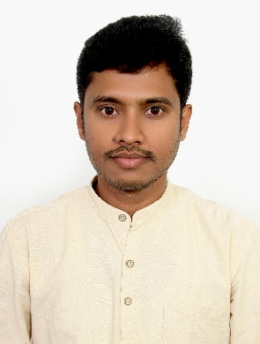

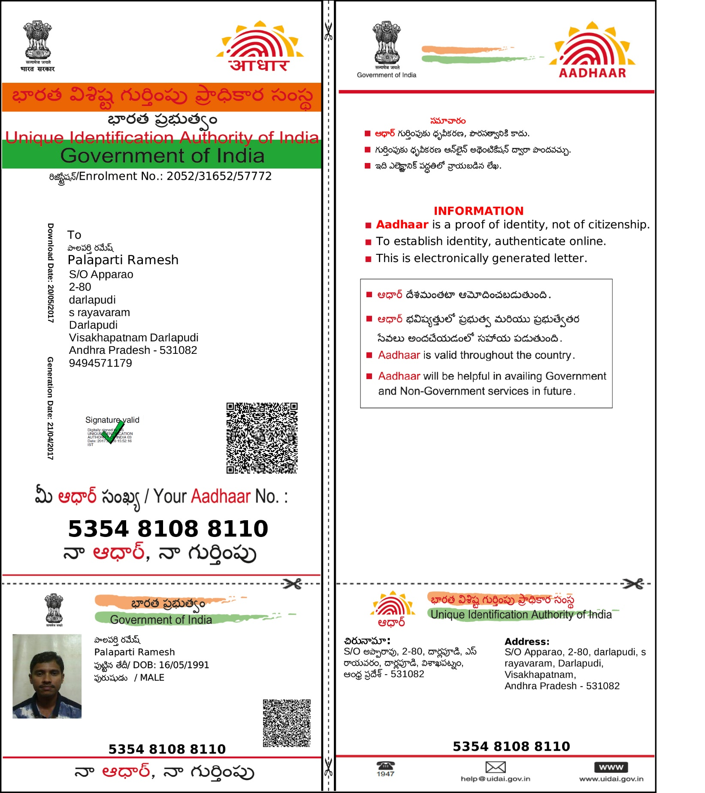

linkedin.com/in/ramesh-palaparti-b32a6648

RAMESH PALAPARTI: .Net Full Stack Developer Email ID: ramesh.palaparti@gmail.com Mobile: +91-9494571179

Experience Summary
- Comprehensive of 7+ years of experience in .Net and .Net Core Web application Design, Development and Deployment.
- Involved in knowledge transfer sessions and worked on requirements gathering, application development, and creation of understanding document, developer interface testing, deployment and support.
- Taking complete ownership on the product in various phases like design, development, deployment and support.
- Taking the leadership on hosting demos to the higher management or clients for giving product overview.
- Joining standup calls with onshore team for the requirement discussion, production issues and work progress as part of project development.
- Good experience in Html, CSS, JavaScript, Typescript, Angular JS, Angular, C#.NET, WEB API, ADO.NET, SQL Server, JIRA, Confluence and GIT.
Skills Summary
Domain |  | Banking, Airlines and Logistics.
Programming Languages |  | C#.NET, SQL, JavaScript, HTML, XML and Typescript.
Operating System / ERP Version |  | Windows
Tools / DB / Packages  / Framework / ERP Components |  | Angular, WEB API, .NET Framework 4.7, .NET Core Framework 3.0, GitLab, JIRA, Confluence, POSTMAN, SOAPUI and SQL Server 2015.
Hardware Platforms |  | Intel series
Professional Experience
- Present working as a Technology Consultant in Virtusa, Hyderabad.
- Worked as a Senior Software Engineer in Dinoosys Technologies Private Limited from April 2018 to 2021 May
- Worked as a Software Engineer in TATA Business Support Services Ltd from December 2016 to 2018 April.
- Worked as a Junior Software Engineer in PLLC Software Solutions Private Limited from December 2014 to 2016 December.
Professional Certifications / Trainings
Attended the trainings on .NET framework 3.5, 4.0, 4.5 and .NET core framework 3.0.
Attended the trainings on Angular.
Work Experience
Project 1
Project Name | Kastle |  | Team Size | 10
Start Date | Aug 2022 |  | End Date | Till Today

Project Description | Kastle is an invoice financing application and it has a workflow to complete an opportunity which receives lead from an onboarding application called SalesLogix. The Smart Summary is a tool for any user to view an application and locate if a user has ownership or what stage the application is at. If a stage is complete this will be shown as follows Data Entry and will have the name of the colleague who completed the activity. If an application is in the Open Pool awaiting activity status will show as Pending with no colleague name attached.
Role & Contribution | - Involved in all the phases of knowledge transfer sessions and worked on application development, requirements gathering, creation of understanding document, developer interface testing, deployment and support.  - Joining the sync up calls with onshore team for the upcoming requirements, resolving the pilot / production issues and project work status as part of project management.
Technology & Tools | Visual Studio 2019, JIRA, Confluence, GIT, GIT Extensions, POSTMAN, HTML, CSS, Typescript, Angular 11, C#.NET, .NET Core.
Project 2
Project Name | NDC (New Distribution Capability) | Team Size | 8
Start Date | Feb 2019 | End Date | May 2021
Project Description | A group of Airlines separated from GDS and formed as NDC. We are developed a common platform for booking tickets for all NDC airlines with B2B and B2C workflows as client requirements.
Role & Contribution | Involved in application development, gathering requirements, creation of understanding document, developer interface testing, deployment and support.
Technology & Tools | Visual Studio 2017, GIT Extensions, POSTMAN, HTML, CSS, jQuery, C#.NET, ADO .NET, WEB API, MS SQL Server 2012.
Project 3
Project Name | Travel Electronic Document (TED) | Team Size | 6
Start Date | Apr 2018 | End Date | Jan 2019
Project Description | - TED is a tool for Galileo Desktop Core Integration component to extracting existing PNR information with MS Word and PDF format.  - It also supports to create own quote with Flights, Hotels and Cars on the single quote and send email with the details.
Role & Contribution | - Involved in application development, gathering requirements, creation of understanding document, developer interface testing, deployment and support.
Technology & Tools | Visual Studio 2017, GIT Extensions, POSTMAN, HTML, CSS, C#.NET, ADO .NET, WEB API, MS  SQL Server 2012.
Key Achievements | Successfully implemented Quote and Existing PNR Details Export into PDF and Word formats using iTextSharp and DocX libraries.
Project 4
Project Name | Motor Vehicle Policy Generating System | Team Size | 6
Start Date | Dec 2016 | End Date | Apr 2018

Project Description | - TBSS is a completely owned subsidiary of TATA Group, and it is offering many services like Voice, Data, Fixed line, Digital Television and Digital media etc.  - We have created the web based responsive application for taking policies for two wheeler and four wheeler New and Rollover vehicles.  - The application is having some of the features like Generate Quotes, Policies and Download Policies etc.
Role & Contribution | - Involved in application development, gathering requirements, creation of understanding document, developer interface testing, deployment and support.
Technology & Tools | Visual Studio 2015, POSTMAN, SOAPUI, MS SQL Server 2008/2012, C#.NET, WEB API,  ADO.NET, Angular JS, .NET framework 3.5/4.0/4.5.
Project 5
Project Name | Onsite Dealership Solutions (ODS) | Team Size | 7
Start Date | Dec 2015 | End Date | Dec 2016
Project Description | Onsite Dealership Solutions provides automotive dealership working solutions for labor and process issues. The services which the application offers are Automotive Detailing, Service Wash, Reconditioning, Lot Management and Vendor Management. The application also has admin part which maintains all the employee details of dealers at various levels like Corporate Level, Site Level, and Dealer Level with different roles and permissions. The application maintains Time- In and Time-Out punches of employees working at dealer locations, which has a separate module called Time Management.
Role & Contribution | - Involved in all the phases of Application development, testing, deployment and support.
Technology & Tools | Visual Studio 2012, MS SQL Server, C#.NET, ASP.NET, ADO.NET, .NET framework 3.5/4.0.
Project 6
Project Name | Golfradar | Team Size | 10
Start Date | Dec 2014 | End Date | Nov 2015
Project Description | Golfradar, based in Vancouver, British Columbia, is the most engaging fantasy golf platform EVER. We welcome every golfer and fan of the sport to join Golfradar and follow the PGA TOUR professional golfer each week, to complete with friends and other enthusiasts and be rewarded for their participation and success.
Role & Contribution | - Involved in design and development of the application using HTML, CSS, jQuery, C#.NET, ASP.NET and MS SQL Server.
Technology & Tools | Visual Studio 2012, MS SQL Server, C#.NET, ASP.NET, ADO.NET, .NET framework 3.5/4.0.
Educational Qualification
Education | Bachelor of Technology (B. TECH) in 2010 to 2013.

